ASSIGNMENT - 9.3   
( 2403A52398 )

# Task 1: Basic Docstring Generation

## 1.1 Manual Implementation

# Task 1: Basic Docstring Generation (AI Version)  
  
def sum_even_odd_numbers(numbers):  
 """Return sum of even and odd numbers in the given list.  
   
 Args:  
 numbers (list): List of integers to process  
   
 Returns:  
 tuple: (even_sum, odd_sum)  
   
 Example:  
 >>> sum_even_odd_numbers([1, 2, 3, 4, 5])  
 (6, 9)  
 """  
 even_sum = 0  
 odd_sum = 0  
   
 for num in numbers:  
 if num % 2 == 0:  
 even_sum += num  
 else:  
 odd_sum += num  
   
 return even_sum, odd_sum  
  
if __name__ == "__main__":  
 test_list = [1, 2, 3, 4, 5, 6, 7, 8, 9, 10]  
 result = sum_even_odd_numbers(test_list)  
 print(f"Input: {test_list}")  
 print(f"Even sum: {result[0]}, Odd sum: {result[1]}")

### Output:

Input: [1, 2, 3, 4, 5, 6, 7, 8, 9, 10]  
Even sum: 30, Odd sum: 25

Screenshot of Manual Code:

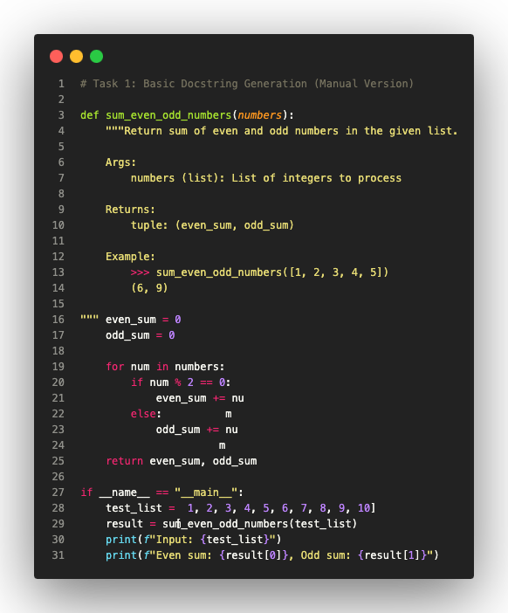

## 1.2 AI-Generated Implementation

*AI Prompt: "Generate comprehensive docstring with Google style, error handling, and examples"*

# Task 1: Basic Docstring Generation (AI-Generated Version)  
  
def sum_even_odd_numbers_ai(numbers):  
 """Calculate the sum of even and odd numbers from a given list.  
  
 This function processes a list of integers and computes separate  
 sums for even and odd values with comprehensive error handling.  
  
 Args:  
 numbers (list of int): A sequence of integer values to process.  
  
 Returns:  
 tuple of (int, int): A two-element tuple containing:  
 - First element: Sum of all even numbers  
 - Second element: Sum of all odd numbers  
  
 Raises:  
 TypeError: If input is not a list or contains non-integers.  
  
 Examples:  
 >>> sum_even_odd_numbers_ai([1, 2, 3, 4, 5, 6])  
 (12, 9)  
 >>> sum_even_odd_numbers_ai([])  
 (0, 0)  
  
 Note:  
 Zero is considered an even number.  
 """  
 if not isinstance(numbers, list):  
 raise TypeError("Input must be a list")  
   
 even_sum = sum(num for num in numbers if isinstance(num, int) and num % 2 == 0)  
 odd_sum = sum(num for num in numbers if isinstance(num, int) and num % 2 != 0)  
   
 return even_sum, odd_sum  
  
if __name__ == "__main__":  
 test_list = [1, 2, 3, 4, 5, 6, 7, 8, 9, 10]  
 result = sum_even_odd_numbers_ai(test_list)  
 print(f"Input: {test_list}")  
 print(f"Even sum: {result[0]}, Odd sum: {result[1]}")

### Output:

Input: [1, 2, 3, 4, 5, 6, 7, 8, 9, 10]  
Even sum: 30, Odd sum: 25

Screenshot of AI-Generated Code:

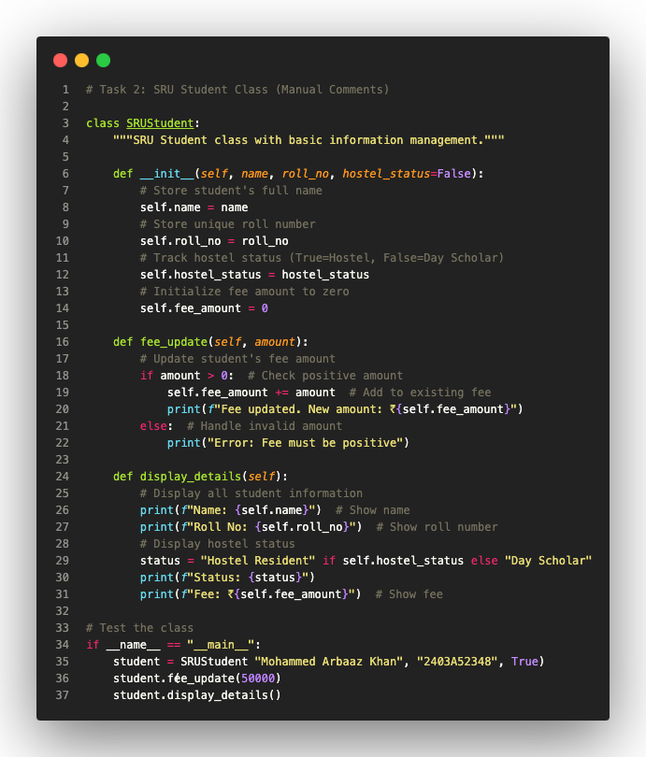

## 1.3 Comparison

Manual Docstring:  
 • Concise and focused  
 • Essential information only  
 • Beginner-friendly  
 • Google style basics  
   
 AI-Generated Docstring:  
 • Comprehensive and detailed  
 • Includes error handling  
 • Professional terminology  
 • Complete Google style with all sections